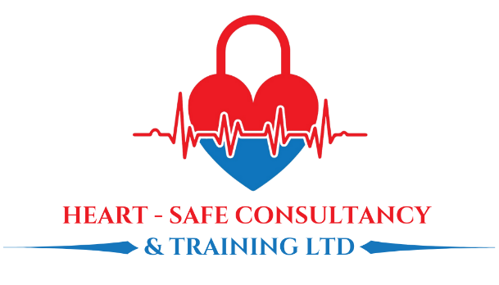
Chandlers House, 6 Wilkinson Road
Cirencester, GL7 1YT
Tel: 01285 654006
Email: info@heart-safe-training.co.uk

Company Registration Number: 8638067

ALL SECTIONS MUST BE COMPLETED including attaching an electronic photo. Please email back electronically to
info@Heart-safe-training.co.uk

Title | Choose from list | Registration Number: NMC/HCPC/GMC/GDC
D.O. B |  | RCS Number * Needed for ATLS* | Click here to enter registration number
First Name: | Click here to enter name. | Place of Work: | Click here to enter place of work
Last Name: |  | Job title & Speciality:
Postal Address:
Post Code: |  | Department: | Click here to enter name.
Gender: | Choose an item. | Any Allergies:
Email: | Click here to enter email | Any Allergies:
Mobile: |  | Emergency Contact Name & Number:
Course Applied for: | Choose an item. | Course date required:
Date of application |  | Any special OR accessibility requirements

*Please insert a passport sized photo
below by clicking the centre icon*
*Cannot add you to a course without this*
HOW TO PAY:
- Bank transfer: Please include your name as the reference on any payments.
Heart Safe Consultancy & Training Ltd
Sort code 04-00-03 Acc. No. 33596964
- Card payment (please let us know and we can send you a payment link)

3. Invoice Employer (please provide ALL the details below)
Employers Name/Address:
Line manager’s email address
Line manager’s Tel No:
Finance email address for invoicing:
Purchase order number:



